**Edge Himmel Park**

**Administrator’s Report**

**February 18th, 2025**

**Current Enrollment**

Himmel Park: 76

* 5 withdrawals since last month due to 10 consecutive absences (2 of the 5 are soon to be graduates who have completed all their course work and are just working on completing their 15 hours of volunteer work)
* 4 new students have started since last month
* 2 students scheduled to start between now and beginning of January
* 1 student at risk of being withdrawn for 10 consecutive absences

Northwest: 63

* 2 students at risk of being withdrawn for 10 consecutive absences

Total: 139

*The FY25 Budget is written with an Average Daily Membership (ADM) of 170

**Enrollment and Recruitment Efforts**

* Open Houses scheduled for the first Tuesday of every month from 5PM-7PM (geared towards 8th graders)
* Email and newsletter campaign geared towards traditional district school’s counseling department as well as other non-profits that support marginalized youth
* Working with a videographer to film student testimonials for Edge’s website
* SunTran Bus stop ads through September
* Edge flyers posted at Lapan College & Career Club
* Edge flyers posted at Live Theatre Workshop
* Edge flyers available at Stand Up For Kids Tucson
* Edge flyers posted at Sporting Chance
* Edge flyers and print materials posted at 4 Boys & Girls Clubhouses
* Edge flyers and print materials are available at EON Youth Lounge on 4th Avenue, operated by Southern Arizona AIDS Foundation.
* Digital ads on Facebook, Instagram, and Google
* Edge flyers and print materials are available at El Rio Community Health Centers.
* Edge flyers are available at Himmel Park and Woods Libraries

**Graduates**

Edge Himmel Park has celebrated 9 graduates so far this year. In addition, 3 seniors should graduate in the next month, and 13 other seniors within range of graduating before the end of May.

**Cognia Accreditation**

Edge is beginning the process towards our accreditation review with Cognia. However, this requires us to pursue a System Accreditation. This requires an initial candidacy review to determine eligibility. Our candidacy review is scheduled for Tuesday, April 22nd. We will submit all the required documentation well before April 22nd. On the 22nd Cognia will be meeting with focus groups of staff and students. They would also like to speak with at least two board members. Please reserve the date on your calendar.

<https://www.cognia.org/>

**Enrollment Initiative For FY26**

Edge Himmel Park is holding an Open House on the first Tuesday of every month for the remainder of the school year from 5PM-7PM. Our partners at Grow Schools created a flyer and are promoting the event on social media through ads. The primary target audience for these Open Houses are 8th graders and their families.

For the February Open House we reached out to AmeriSchools and La Paloma, two K-8 charter schools whose 8th graders will be looking for a new school for next year. Five families attended and one student completed the pre-registration form that night.

**2 New Community Partnerships**

**All In Youth Pickleball** is teaching a pickleball PE class at Edge Himmel Park on Wednesdays during 3rd period. All In Youth pickleball has provided pickleball equipment, water bottles, and mentoring and coaching to Edge students. They are helping students learn the rules and the fundamentals of the sport and focus on building character and resilience in youth. Each class starts with a group conversation around the purpose and objectives of the day and ends with reflection, feedback, and praise. All In Youth is paying for interested students to participate in upcoming pickleball tournaments. We are in conversations with them regarding Edge having a competitive pickleball team and are discussing ways to host a pickleball tournament as a fundraiser for Edge.

<https://allinyouthpickleball.org/>

**Tu Nudito**, will be teaching a “Growing through grief class” at Himmel Park on Wednesdays beginning in the 4th quarter. Tu Nudito is a community leader in helping individuals and families through the grief process through bi-monthly support groups. Students participating in the class will leave with a Greif Resource Toolkit to use at home.

Tu Nudito will also be facilitating a professional learning workshop for our staff on the topic of supporting students dealing with grief. This training is scheduled for Monday, March 24th from 1PM-3PM.

<https://tunidito.org/>

**Community Conversation On Gun Violence**

As part of our continued collaboration with Goodwill of Southern Arizona, Goodwill will be hosting a Community Conversation with interested Edge Himmel Park students on Tuesday, February 18th from 11AM-12:30PM. This conversation is part of Goodwill’s Community Violence Intervention Program. Numerous Edge students have been impacted by gun violence. Feedback from students will be shared with community leaders in government and social services.

**Upcoming Ways To Support Edge**

* If you learn about grant opportunities, please let Edge administration know.
* If you have people in your personal or professional networks who might connect with Edge’s mission and vision and might have the capacity to give, please make an introduction.
* Forward the video below to those in your network:

<https://www.youtube.com/watch?v=FAXaKI5Xx3U>

[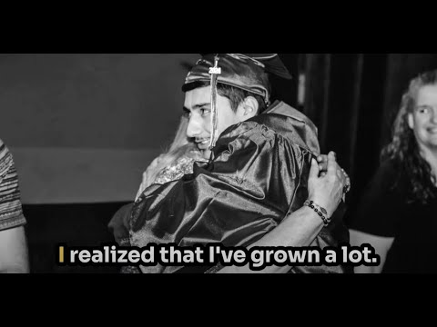](https://www.youtube.com/watch?v=FAXaKI5Xx3U)

* Participate in professional learning with our staff and/or eat lunch with staff on our Professional Learning Day on Monday, March 24th at from 8AM-3PM at Edge Himmel Park.
* Participate in 3rd Quarter Honor’s Assembly on Friday, April 4th from 12PM-12:30PM
* Participate in a focus group with Cognia (our accreditation body) on Aprill 22nd.
* Help plan Teacher Appreciation Week (May 5th-9th)
* Help plan, fundraise, decorate for Edge’s Prom (May 10th)